Social Media Content and Graphics

Facebook Copy | X Copy | Instagram Copy | Media Asset
Veterans living outside the U.S. can connect with the Veterans Crisis Line through chat anytime, anywhere: VeteransCrisisLine.net/Chat. | #Veterans living outside the U.S. can connect with the #VeteransCrisisLine through chat anytime, anywhere: VeteransCrisisLine.net/Chat. | #Veterans living outside the U.S. can connect with the #VeteransCrisisLine through chat anytime, anywhere: VeteransCrisisLine.net/Chat. | Facebook/Instagram  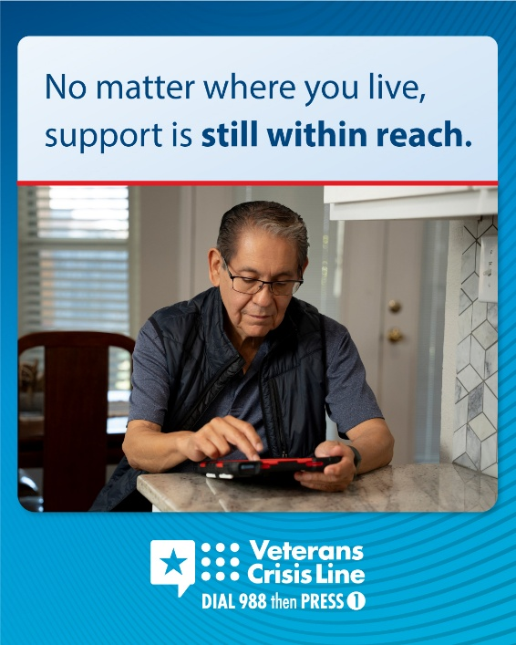  Instagram  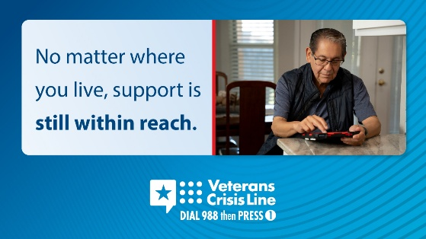
If you're experiencing a crisis or know someone who is, the Veterans Crisis Line can help.  To start a chat: VeteransCrisisLine.net/Chat. | If you're experiencing a crisis or know someone who is, the #VeteransCrisisLine can help.  To start a chat: VeteransCrisisLine.net/Chat. | If you're experiencing a crisis or know someone who is, the #VeteransCrisisLine can help.  To start a chat: VeteransCrisisLine.net/Chat. | Facebook/Instagram    X  
Veterans outside the U.S. can connect with the Veterans Crisis Line through secure, confidential chat, no phone call needed.  Reach out when you need support: VeteransCrisisLine.net/Chat. | #Veterans outside the U.S. can connect with the #VeteransCrisisLine through secure, confidential chat, no phone call needed.  Reach out when you need support: VeteransCrisisLine.net/Chat. | #Veterans outside the U.S. can connect with the #VeteransCrisisLine through secure, confidential chat, no phone call needed.  Reach out when you need support: VeteransCrisisLine.net/Chat. | Facebook/Instagram    X  
Veterans living abroad can connect with the Veterans Crisis Line via chat online for immediate support.  Chat now at VeteransCrisisLine.net/Chat. | #Veterans living abroad can connect with the #VeteransCrisisLine via chat online for immediate support.  Chat now at VeteransCrisisLine.net/Chat. | #Veterans living abroad can connect with the #VeteransCrisisLine via chat online for immediate support.  Chat now at VeteransCrisisLine.net/Chat. | Facebook/ Instagram    X  

