U.S. Department of Veterans Affairs Office of Mental Health & Suicide Prevention

Veterans Crisis Line Social Media Posts – Last updated August 31, 2021

Facebook Copy (280 characters) | Twitter Copy (280 characters) | Instagram Copy | Media Asset
You don’t have to fight alone. If you’re a Veteran having thoughts of suicide, call the Veterans Crisis Line now at 1-800-273-8255 and Press 1. | Help is always available. If you’re a #Veteran considering suicide, call the #VeteransCrisisLine now at 1-800-273-8255 and Press 1. | If you’re a #Veteran having suicidal thoughts, call the #VeteransCrisisLine now at 1-800-273-8255 and Press 1. #SuicidePrevention #SuicideAwareness | Facebook/Twitter Image  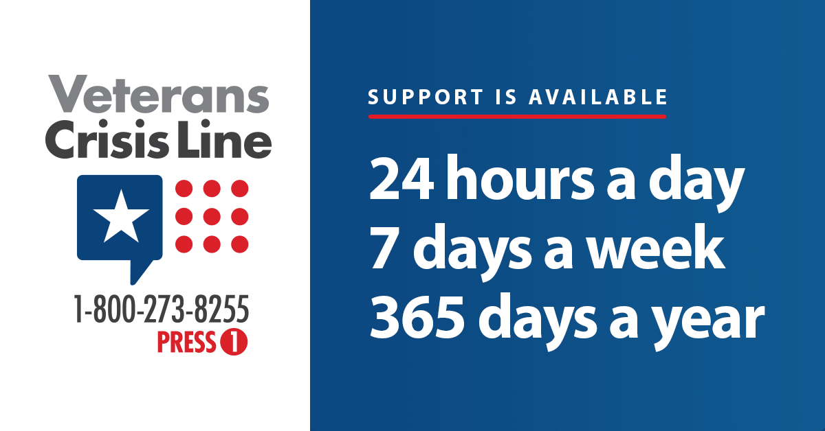  Instagram Image  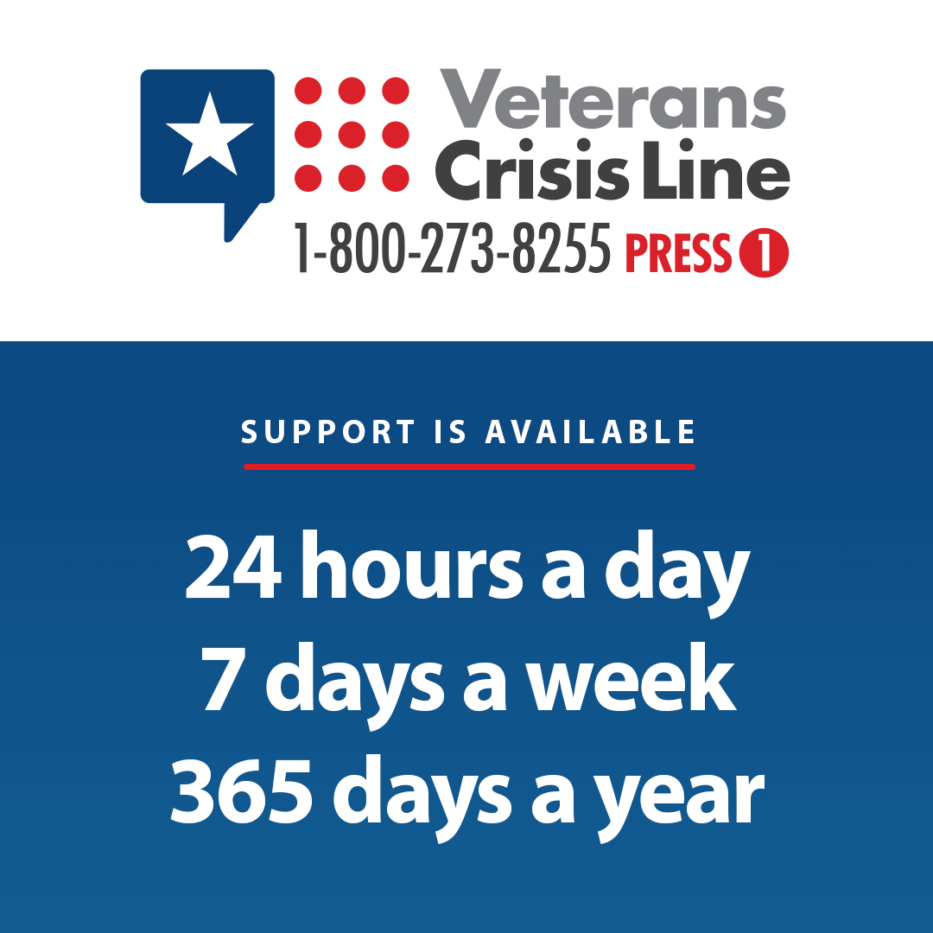
Add the Veterans Crisis Line to your contacts in case you or a Veteran friend needs it. Be prepared. Do it now. VeteransCrisisLine.net | Save the #VeteransCrisisLine number to your phone and encourage your fellow #Veterans to do the same. Be prepared. VeteransCrisisLine.net | Save the #VeteransCrisisLine number to your contacts. Be prepared in case you or a #Veteran friend needs it. VeteransCrisisLine.net #SuicidePrevention #SuicideAwareness | Facebook/Twitter Image  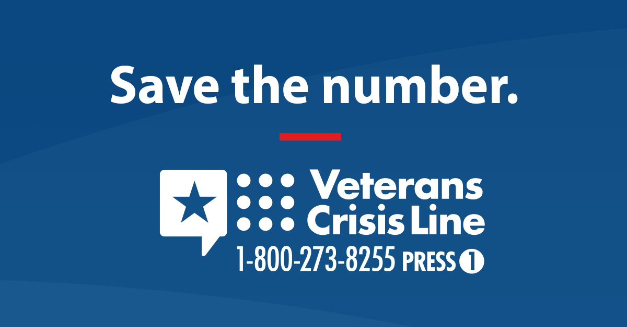  Instagram Image  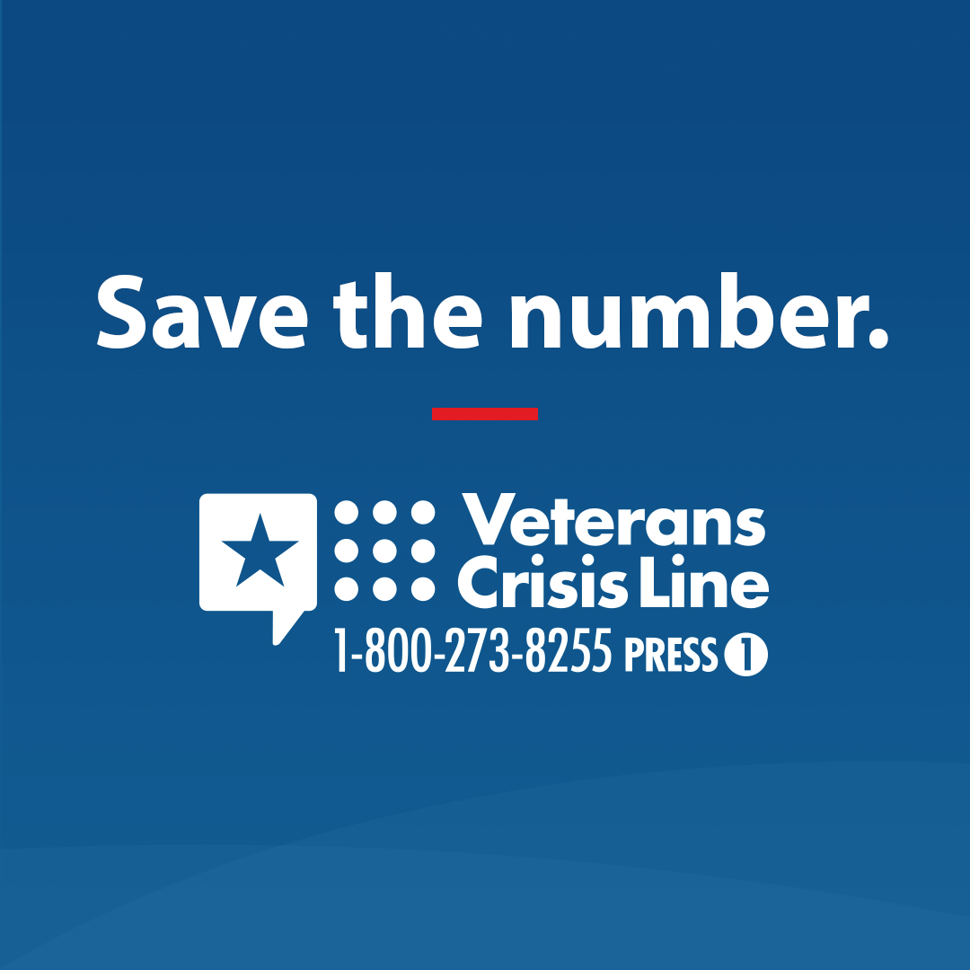
If you’re having suicidal thoughts, call the Veterans Crisis Line now: 1-800-273-8255 and Press 1. It can get better. | If you’re having suicidal thoughts, call the #VeteransCrisisLine now: 1-800-273-8255 and Press 1. It can get better. | If you’re having suicidal thoughts, call the #VeteransCrisisLine now: 1-800-273-8255 and Press 1. It can get better. #SuicidePrevention #SuicideAwareness | Facebook/Twitter  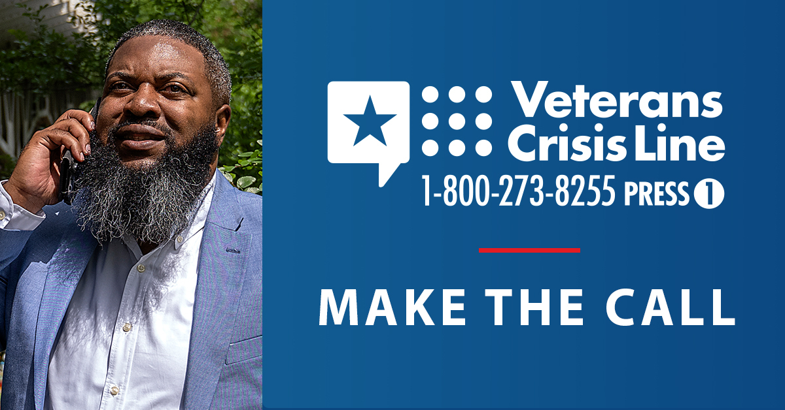  Instagram  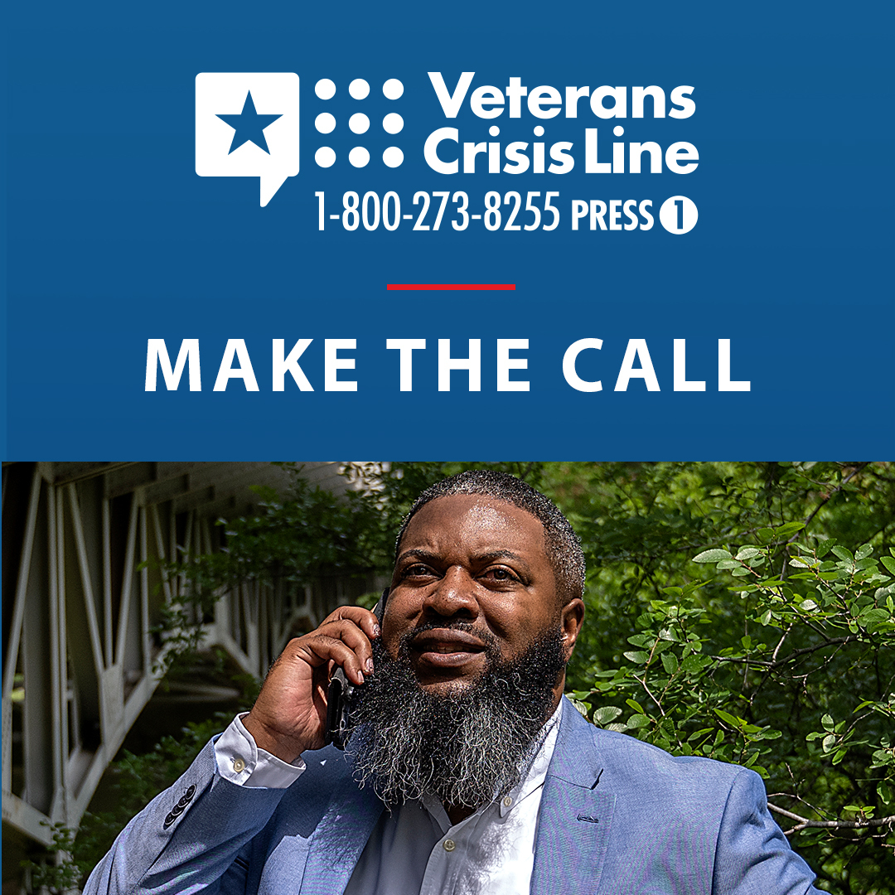
The Veterans Crisis Line is available 24/7 to give crisis support to all Veterans and their loved ones. Learn more at VeteransCrisisLine.net. | The #VeteransCrisisLine is available 24/7 to give crisis support to all Veterans and their loved ones. Learn more at VeteransCrisisLine.net. | The #VeteransCrisisLine is available 24/7 to give crisis support to all Veterans and their loved ones. Learn more at VeteransCrisisLine.net. #SuicidePrevention #SuicideAwareness | Facebook/Twitter  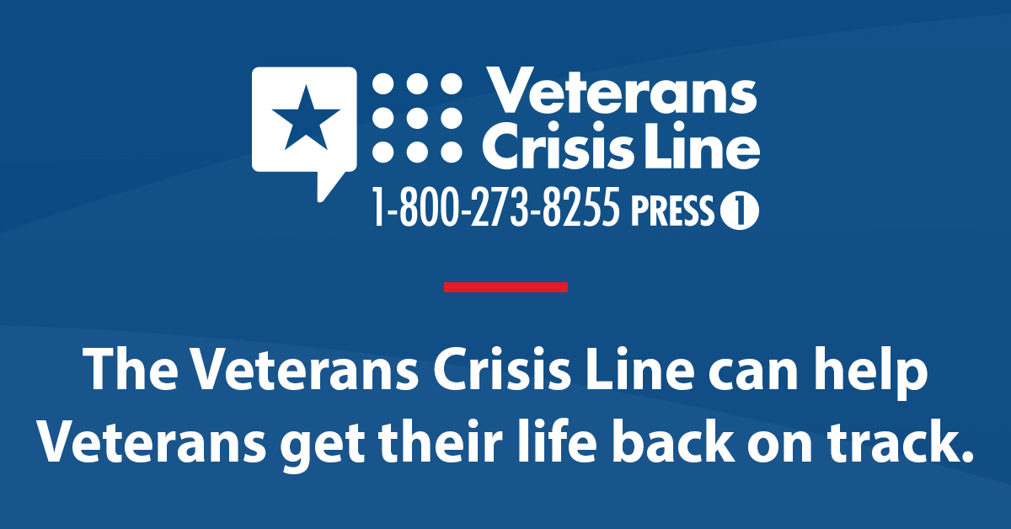  Instagram  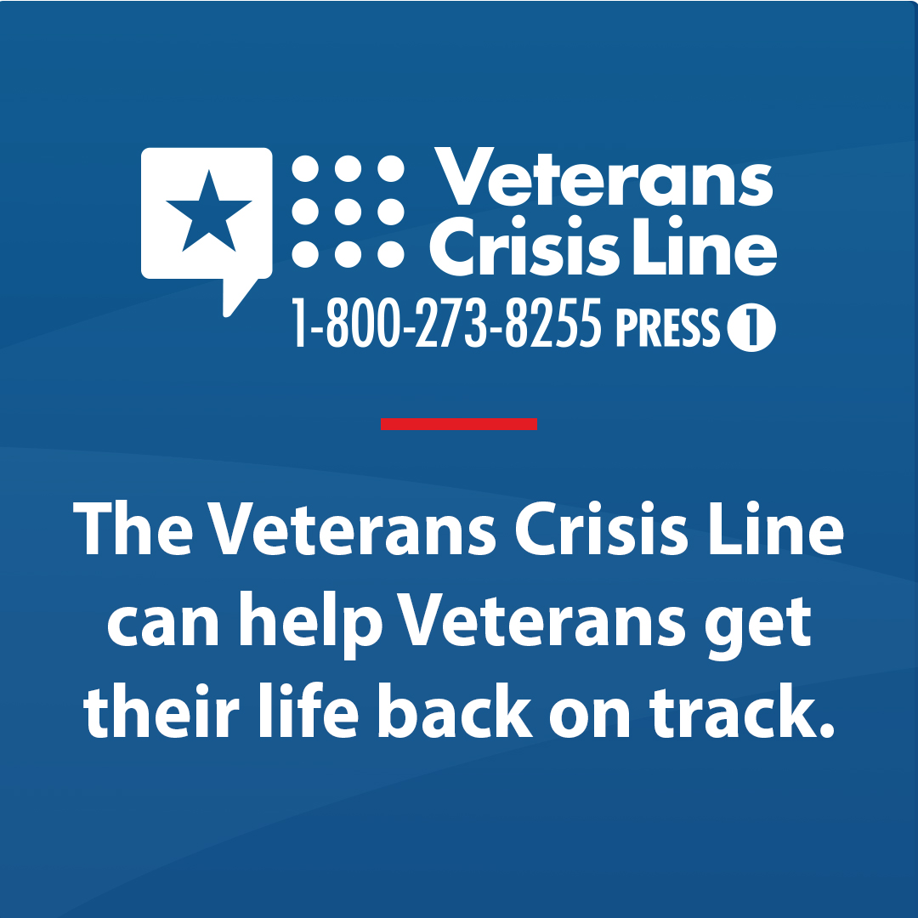
We’re here to help. If you’re having suicidal thoughts, call the Veterans Crisis Line at 1-800-273-8255 and Press 1. Support is available 24/7.  VeteransCrisisLine.net | We’re here to help. If you’re having suicidal thoughts, call the #VeteransCrisisLine at 1-800-273-8255 and Press 1. Support is available 24/7.  VeteransCrisisLine.net | We’re here to help. If you’re having suicidal thoughts, call the #VeteransCrisisLine at 1-800-273-8255 and Press 1. Support is available 24/7.  VeteransCrisisLine.net  #SuicidePrevention #SuicideAwareness | Facebook/Twitter  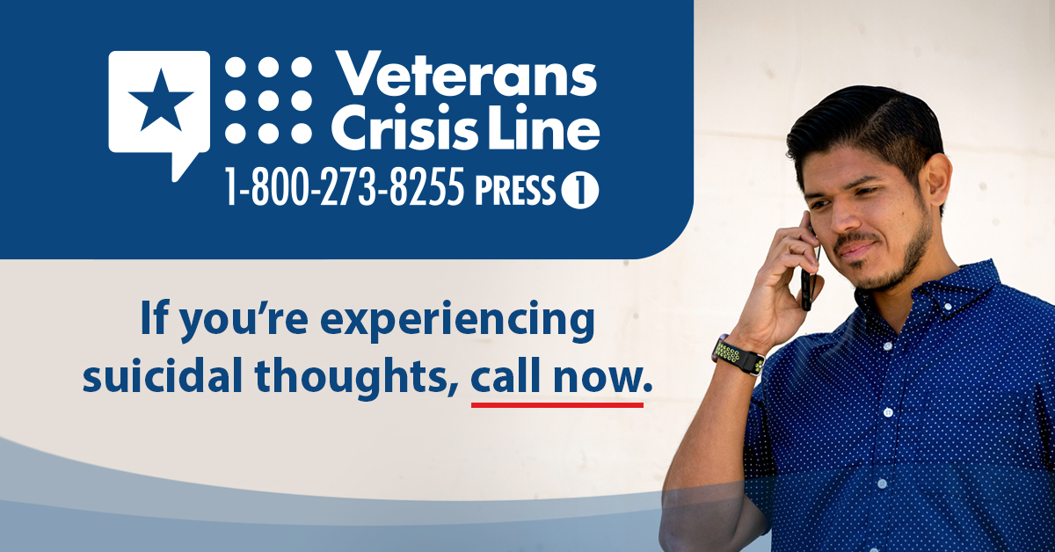  Instagram  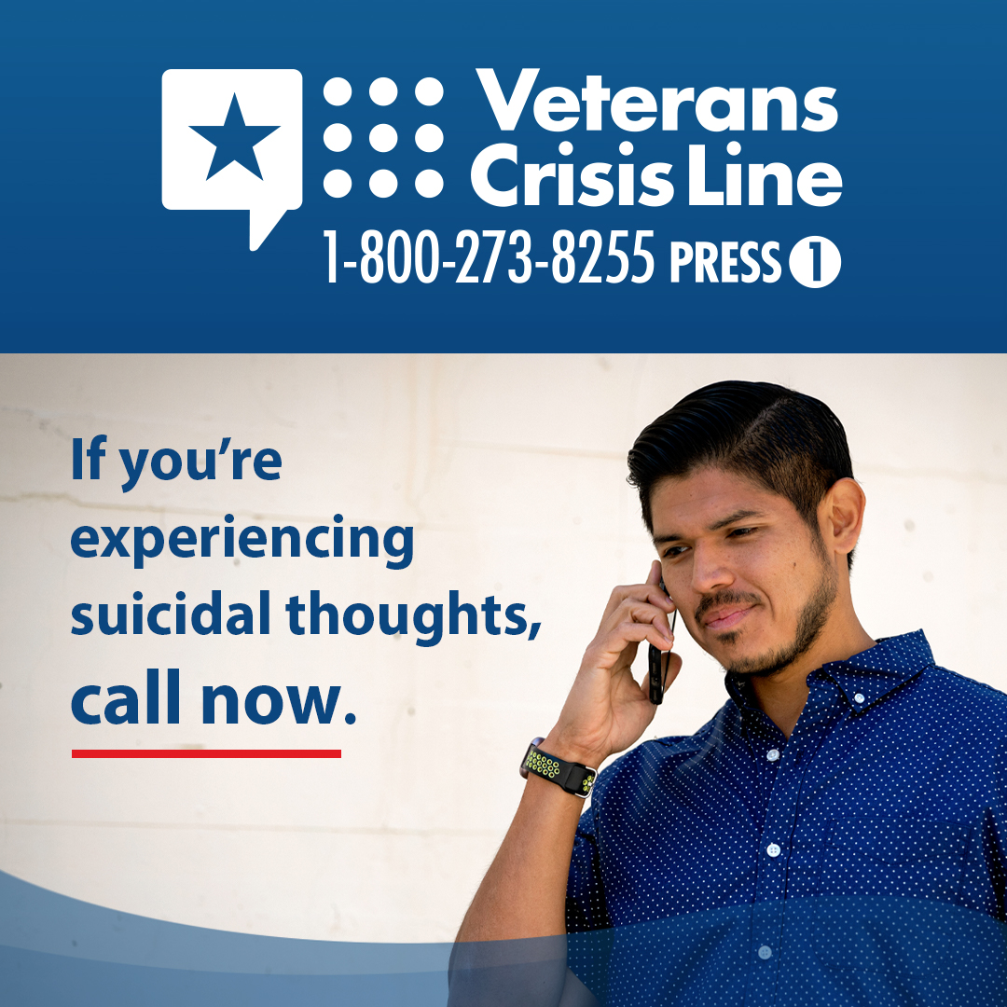
Save the Veterans Crisis Line number in your phone so you can be prepared to help a Veteran in crisis or yourself.  VeteransCrisisLine.net | Save the #VeteransCrisisLine number in your phone so you can be prepared to help a #Veteran in crisis or yourself.  VeteransCrisisLine.net | Save the #VeteransCrisisLine number in your phone so you can be prepared to help a #Veteran in crisis or yourself.  VeteransCrisisLine.net #SuicidePrevention #SuicideAwareness | Facebook/Twitter  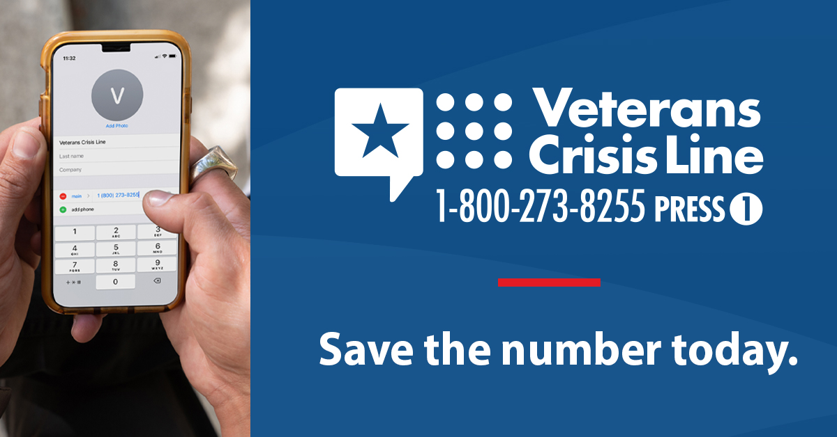  Instagram  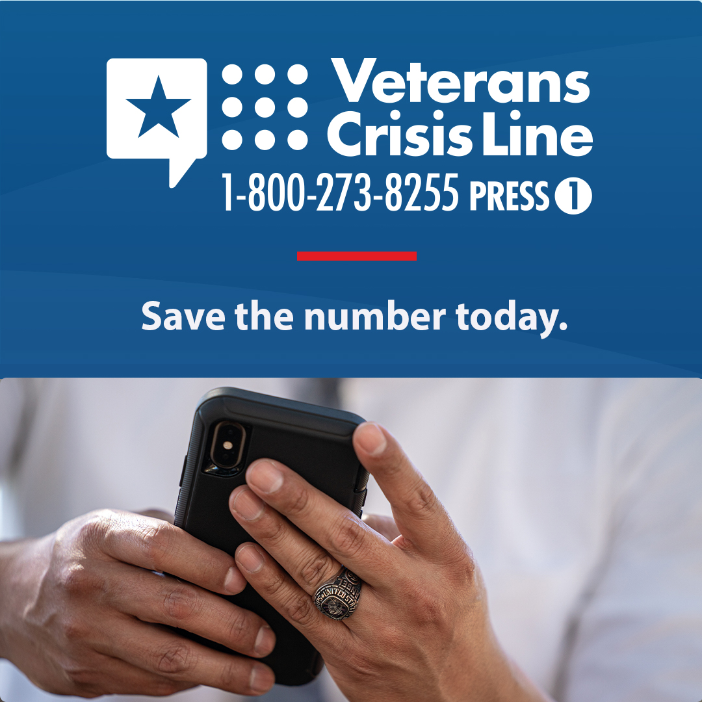
If you’re concerned about a Veteran in your life, make sure they know about the Veterans Crisis Line. You can even call together: 1-800-273-8255 and Press 1. VeteransCrisisLine.net | If you’re concerned about a Veteran in your life, make sure they know about the #VeteransCrisisLine. You can even call together: 1-800-273-8255 and Press 1. VeteransCrisisLine.net | If you’re concerned about a Veteran in your life, make sure they know about the #VeteransCrisisLine. You can even call together: 1-800-273-8255 and Press 1. VeteransCrisisLine.net  #SuicidePrevention #SuicideAwareness | Facebook/Twitter  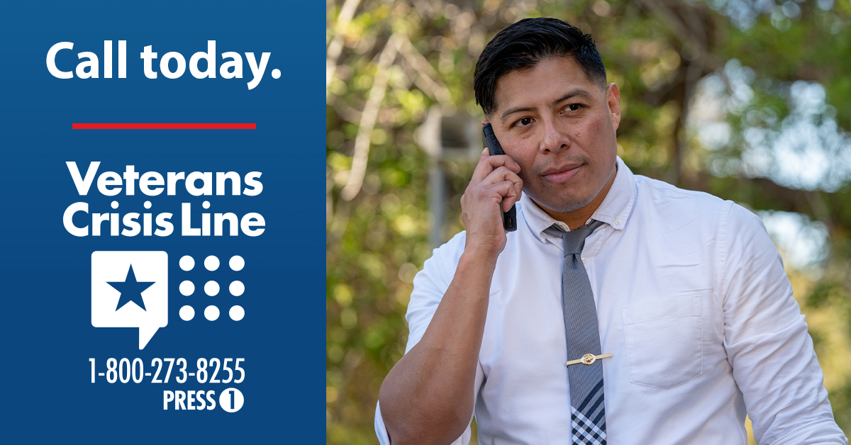  Instagram  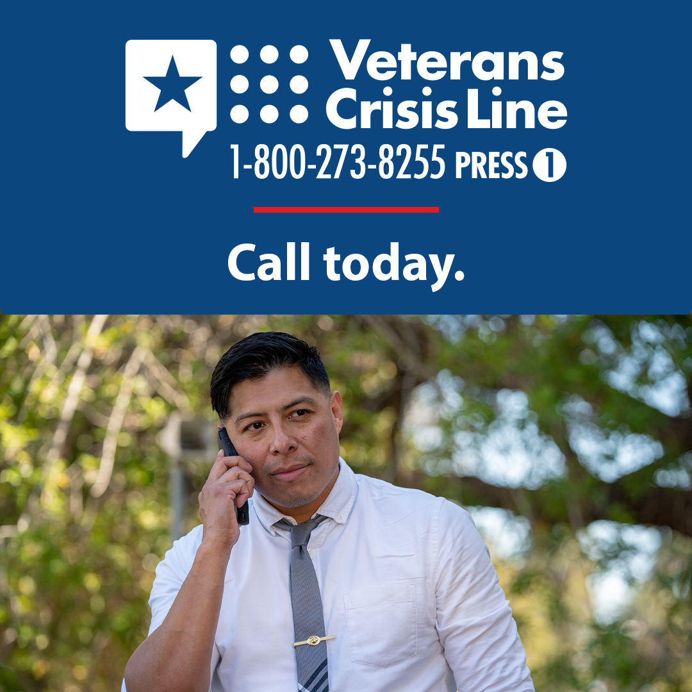
Help is available to you day or night. If you’re in crisis, call 1-800-273-8255 and Press 1, text 838255, or chat at VeteransCrisisLine.net/chat to connect with the Veterans Crisis Line. | Help is available to you day or night. If you’re in crisis, call 1-800-273-8255 and Press 1, text 838255, or chat at VeteransCrisisLine.net/chat to connect with the #VeteransCrisisLine. | Help is available to you day or night. If you’re in crisis, call 1-800-273-8255 and Press 1, text 838255, or chat at VeteransCrisisLine.net/chat to connect with the #VeteransCrisisLine.  #SuicidePrevention #SuicideAwareness | Facebook/Twitter  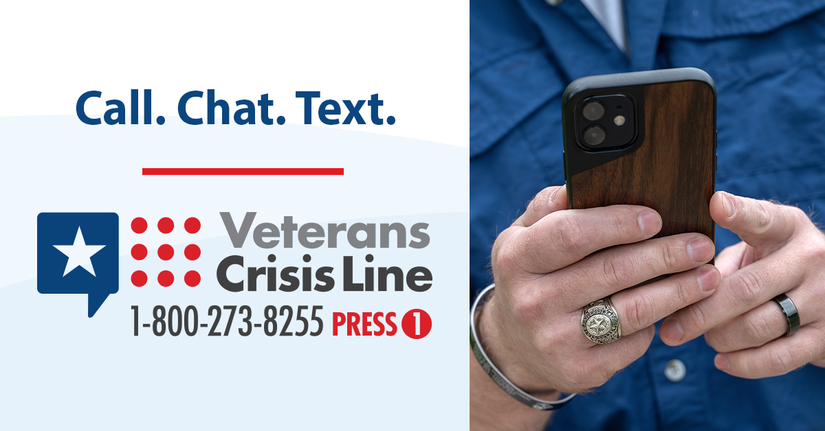  Instagram  