Social Media Content and Graphics

Facebook Copy | Twitter Copy | Instagram Copy | Media Asset
You don’t have to be enrolled in VA benefits or health care to connect with the Veterans Crisis Line. Call, chat, or text to reach responders day or night.  VeteransCrisisLine.net | You don’t have to be enrolled in VA benefits or health care to connect with the #VeteransCrisisLine. Call, chat, or text to reach responders day or night.  VeteransCrisisLine.net | You don’t have to be enrolled in VA benefits or health care to connect with the #VeteransCrisisLine. Call, chat, or text to reach responders day or night.  VeteransCrisisLine.net  #SuicidePrevention  #SuicideAwareness | Facebook/Twitter  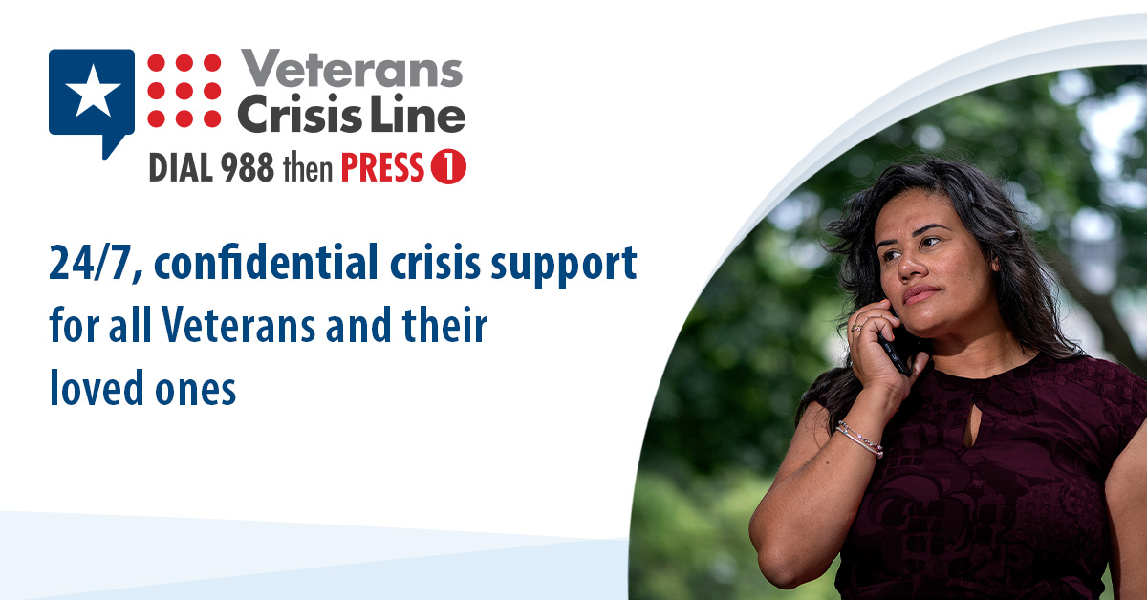  Instagram  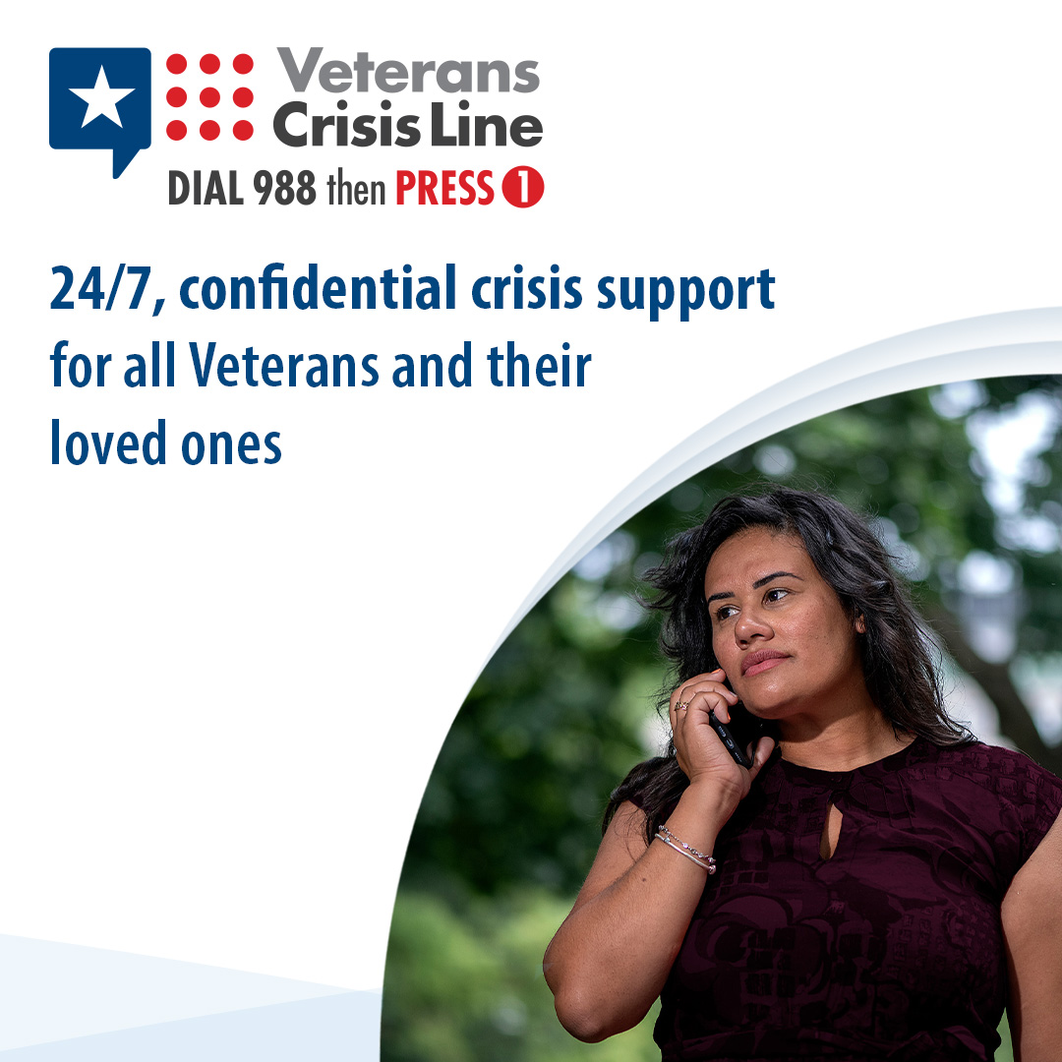
If you choose to share your contact information, Veterans Crisis Line responders can connect you with the local resources you need.  VeteransCrisisLine.net | If you choose to share your contact information, #VeteransCrisisLine responders can connect you with the local resources you need.  VeteransCrisisLine.net | If you choose to share your contact information, #VeteransCrisisLine responders can connect you with the local resources you need.  VeteransCrisisLine.net  #SuicidePrevention  #SuicideAwareness | Facebook/Twitter  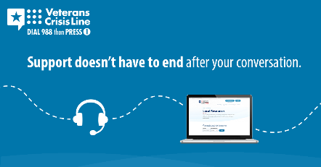  Instagram  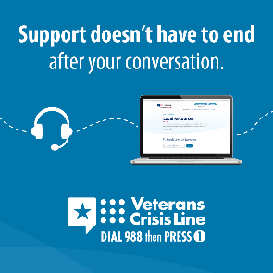
Are you a Veteran in crisis or concerned about one? Call the Veterans Crisis Line—Dial 988 then Press 1. You don’t have to be enrolled in VA benefits or health care to get free, confidential help right now. VeteransCrisisLine.net | Are you a #Veteran in crisis or concerned about one? Call the #VeteransCrisisLine—Dial 988 then Press 1. You don’t have to be enrolled in VA benefits or health care to get free, confidential help right now. VeteransCrisisLine.net | Are you a #Veteran in crisis or concerned about one? Call the #VeteransCrisisLine—Dial 988 then Press 1. You don’t have to be enrolled in VA benefits or health care to get free, confidential help right now. VeteransCrisisLine.net  #SuicidePrevention  #SuicideAwareness | Facebook/Twitter  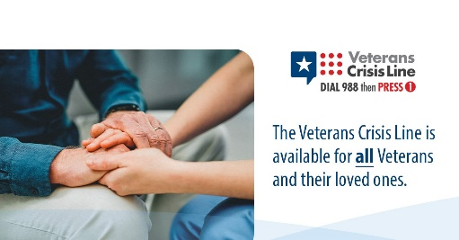  Instagram  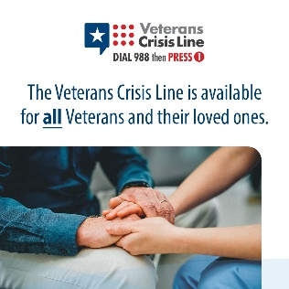
If you’re a Veteran in crisis or concerned about one, responders are available 24/7 to listen and help—Dial 988 then Press 1, chat at VeteransCrisisLine.net/Chat, or text 838255. | If you’re a Veteran in crisis or concerned about one, responders are available 24/7 to listen and help—Dial 988 then Press 1, chat at VeteransCrisisLine.net/Chat, or text 838255. | If you’re a Veteran in crisis or concerned about one, responders are available 24/7 to listen and help—Dial 988 then Press 1, chat at VeteransCrisisLine.net/Chat, or text 838255.  #SuicidePrevention #SuicideAwareness | Facebook/Twitter  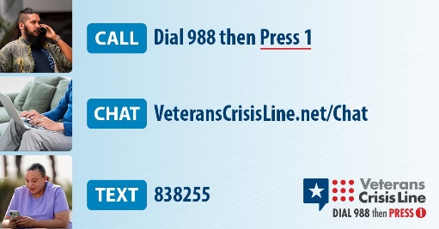  Instagram  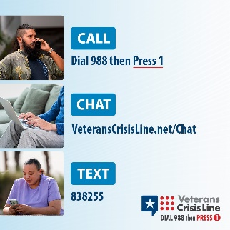
The Veterans Crisis Line provides confidential crisis support to all Veterans and their loved ones.  Learn more at VeteransCrisisLine.net. | The #VeteransCrisisLine provides confidential crisis support to all #Veterans and their loved ones.  Learn more at VeteransCrisisLine.net. | The #VeteransCrisisLine provides confidential crisis support to all #Veterans and their loved ones.  Learn more at VeteransCrisisLine.net.  #SuicidePrevention  #SuicideAwareness | Facebook/Twitter  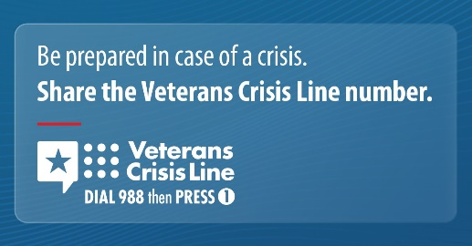  Instagram  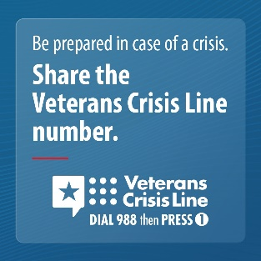
If you’re a Veteran having thoughts of suicide, the Veterans Crisis Line is here for you right now.  Call (Dial 988 then Press 1), chat (VeteransCrisisLine.net/Chat), or  text (838255) for 24/7 crisis support. | If you’re a #Veteran having thoughts of suicide, the #VeteransCrisisLine is here for you right now.  Call (Dial 988 then Press 1), chat (VeteransCrisisLine.net/Chat), or  text (838255) for 24/7 crisis support. | If you’re a #Veteran having thoughts of suicide, the #VeteransCrisisLine is here for you right now.  Call (Dial 988 then Press 1), chat (VeteransCrisisLine.net/Chat), or  text (838255) for 24/7 crisis support.  #SuicidePrevention  #SuicideAwareness | Facebook/Twitter  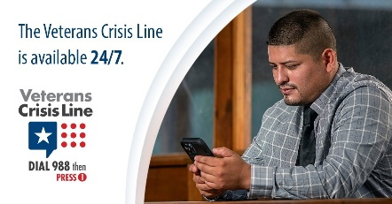  Instagram  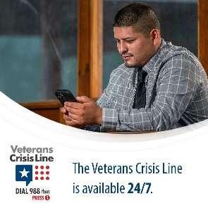
Suicide is preventable and support is available. Veterans Crisis Line responders can connect you with resources and help you make a plan to stay safe. Learn more: VeteransCrisisLine.net. | Suicide is preventable and support is available. #VeteransCrisisLine responders can connect you with resources and help you make a plan to stay safe. Learn more: VeteransCrisisLine.net. | Suicide is preventable and support is available. #VeteransCrisisLine responders can connect you with resources and help you make a plan to stay safe. Learn more: VeteransCrisisLine.net.  #SuicidePrevention  #SuicideAwareness | Facebook/Twitter  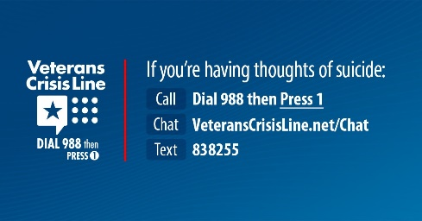  Instagram  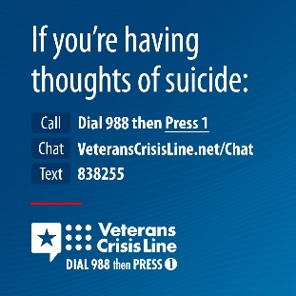
24 hours a day, 7 days a week, 365 days a year, the Veterans Crisis Line offers support to Veterans who are having thoughts of suicide. To connect, Dial 988 then Press 1, chat at VeteransCrisisLine.net/Chat, or text 838255. | 24 hours a day, 7 days a week, 365 days a year, the Veterans Crisis Line offers support to Veterans who are having thoughts of suicide. To connect, Dial 988 then Press 1, chat at VeteransCrisisLine.net/Chat, or text 838255. | 24 hours a day, 7 days a week, 365 days a year, the Veterans Crisis Line offers support to Veterans who are having thoughts of suicide. To connect, Dial 988 then Press 1, chat at VeteransCrisisLine.net/Chat, or text 838255.  #SuicidePrevention #SuicideAwareness | Facebook/Twitter  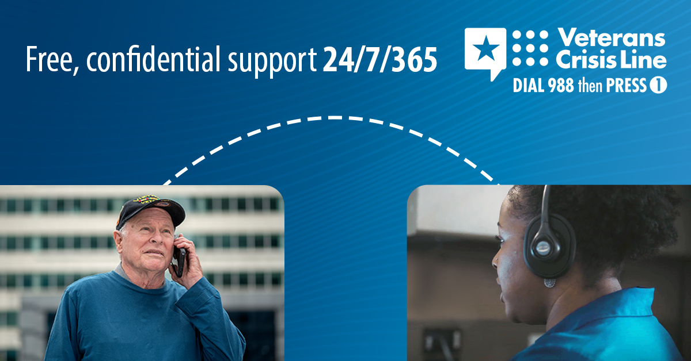  Instagram  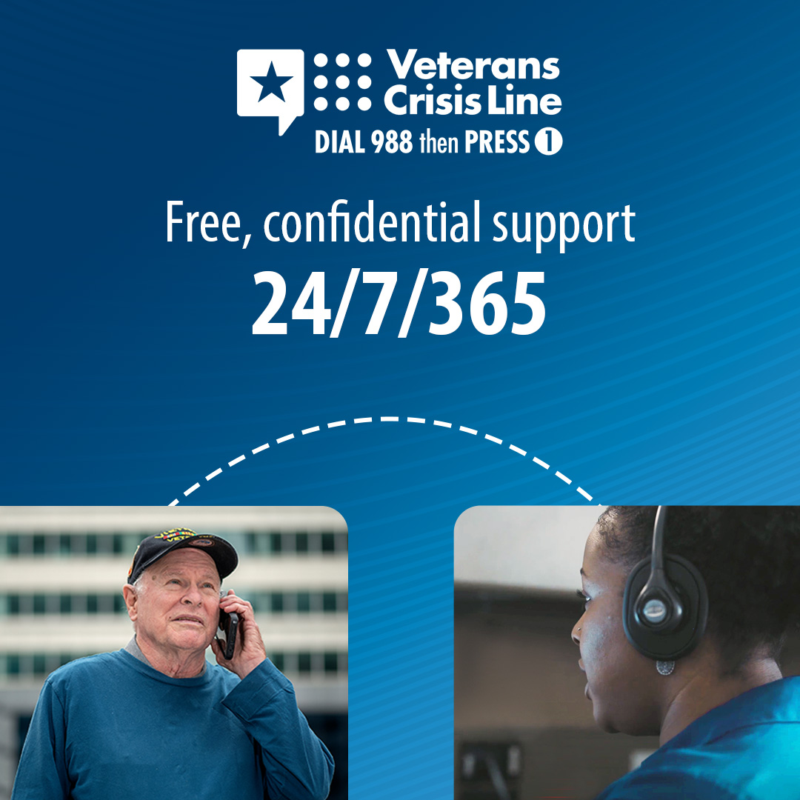
Asking a Veteran you care about if they’re having thoughts of suicide isn’t easy, but it could save their life. Learn how to start the conversation at VeteransCrisisLine.net/Crisis  ConversationHandout. | Asking a #Veteran you care about if they’re having thoughts of suicide isn’t easy, but it could save their life. Learn how to start the conversation at VeteransCrisisLine.net/Crisis  ConversationHandout. | Asking a #Veteran you care about if they’re having thoughts of suicide isn’t easy, but it could save their life. Learn how to start the conversation at VeteransCrisisLine.net/Crisis  ConversationHandout.  #SuicidePrevention  #SuicideAwareness | Facebook/Twitter  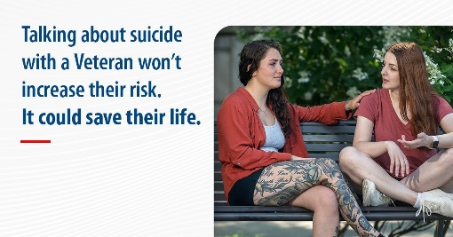  Instagram  