Social Media Content and Graphics

Facebook Copy | X (formerly Twitter) Copy | Instagram Copy | Media Asset
Are you struggling to navigate life after the service? We get it and we can help. The Veterans Crisis Line is available any time, day or night.  Dial 988 then Press 1, chat at VeteransCrisisLine.net/Chat, or text 838255. | Are you struggling to navigate life after the service? We get it and we can help. The #VeteransCrisisLine is available any time, day or night.  Dial 988 then Press 1, chat at VeteransCrisisLine.net/Chat, or text 838255. | Are you struggling to navigate life after the service? We get it and we can help. The #VeteransCrisisLine is available any time, day or night.  Dial 988 then Press 1, chat at VeteransCrisisLine.net/Chat, or text 838255.  #SuicidePrevention  #SuicideAwareness | Facebook/X  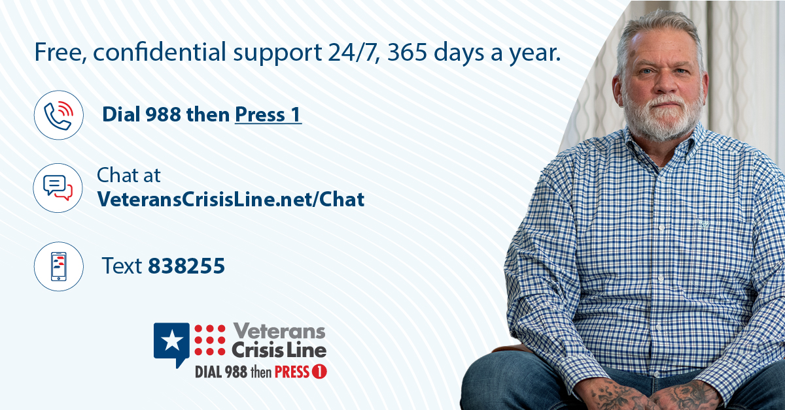  Instagram  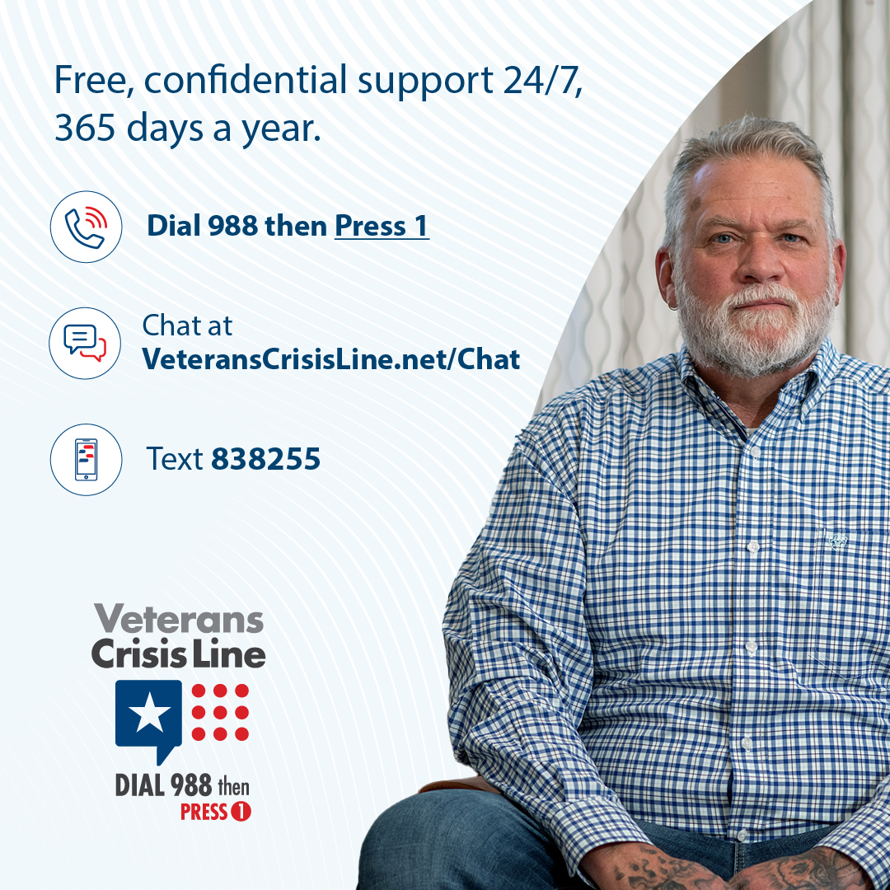
There is no single cause of suicide, but some actions and behaviors may indicate a Veteran wants or needs help. Learn the warning signs and where to find support: VeteransCrisisLine.net/Signs-Of-Crisis | There is no single cause of suicide, but some actions and behaviors may indicate a #Veteran wants or needs help. Learn the warning signs and where to find support: VeteransCrisisLine.net/Signs-Of-Crisis | There is no single cause of suicide, but some actions and behaviors may indicate a #Veteran wants or needs help. Learn the warning signs and where to find support: VeteransCrisisLine.net/Signs-Of-Crisis  #SuicidePrevention  #SuicideAwareness | Facebook/X  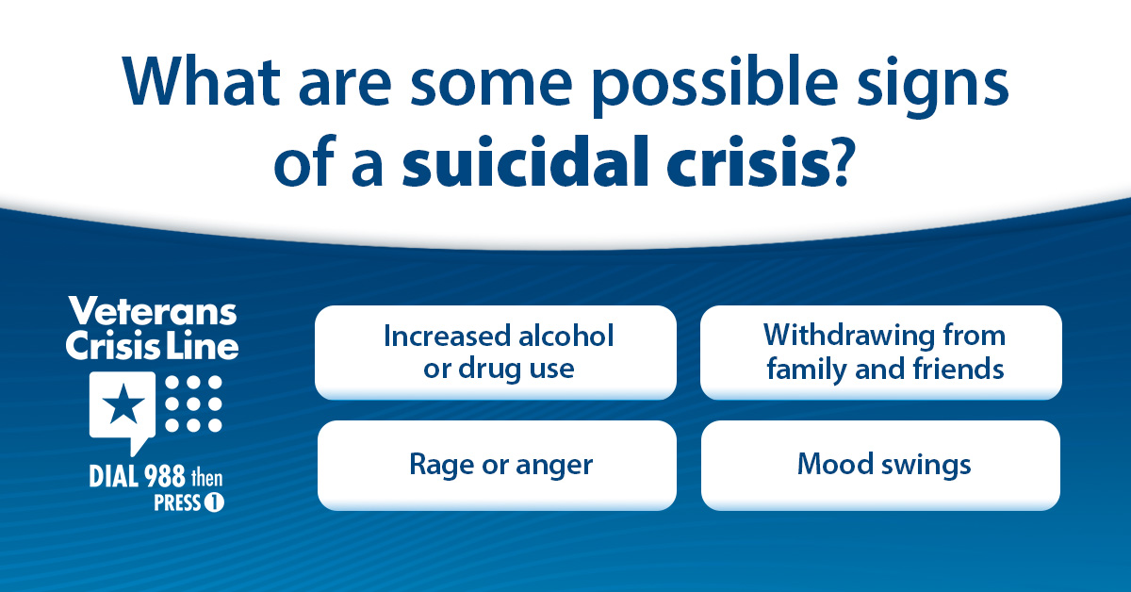  Instagram  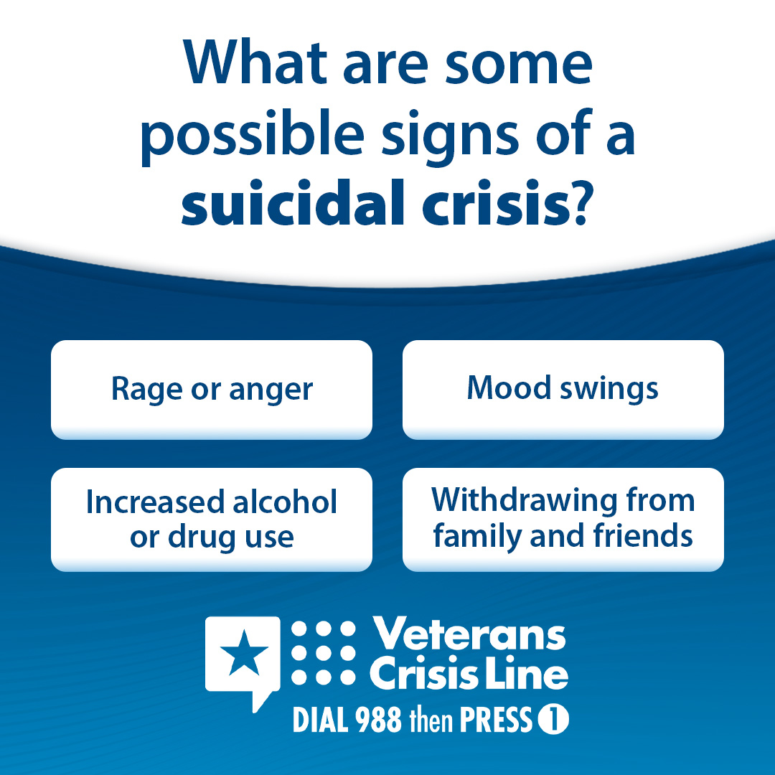
No matter where you are or what you’re going through, the Veterans Crisis Line helps all Veterans find immediate support. Dial 988 then Press 1, chat at VeteransCrisisLine.net/Chat, or text 838255 now. | No matter where you are or what you’re going through, the #VeteransCrisisLine helps all #Veterans find immediate support. Dial 988 then Press 1, chat at VeteransCrisisLine.net/Chat, or text 838255 now. | No matter where you are or what you’re going through, the #VeteransCrisisLine helps all #Veterans find immediate support. Dial 988 then Press 1, chat at VeteransCrisisLine.net/Chat, or text 838255 now.  #SuicidePrevention #SuicideAwareness | Facebook/X  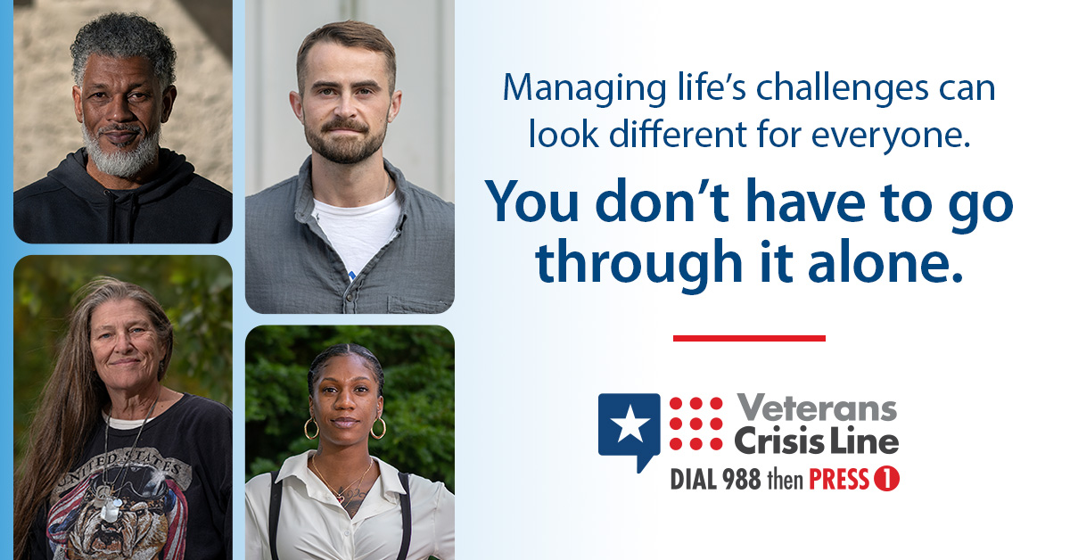  Instagram  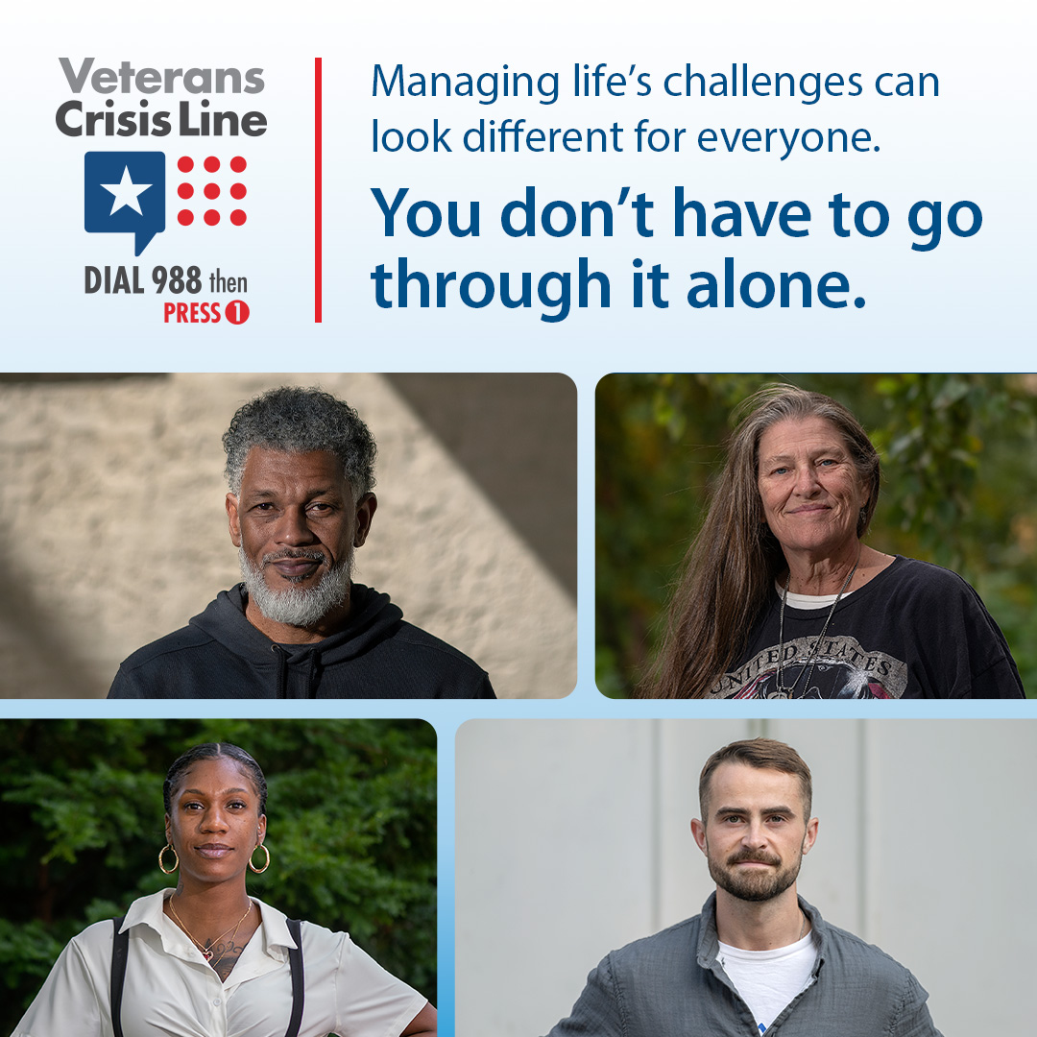
Veterans Crisis Line responders can connect you with 24/7, confidential crisis support. If you’re a Veteran in crisis or concerned about one, Dial 988 then Press 1, chat at VeteransCrisisLine.net/Chat, or text 838255 now. | #VeteransCrisisLine responders can connect you with 24/7, confidential crisis support. If you’re a Veteran in crisis or concerned about one, Dial 988 then Press 1, chat at VeteransCrisisLine.net/Chat, or text 838255 now. | #VeteransCrisisLine responders can connect you with 24/7, confidential crisis support. If you’re a Veteran in crisis or concerned about one, Dial 988 then Press 1, chat at VeteransCrisisLine.net/Chat, or text 838255 now.  #SuicidePrevention #SuicideAwareness | Facebook/X  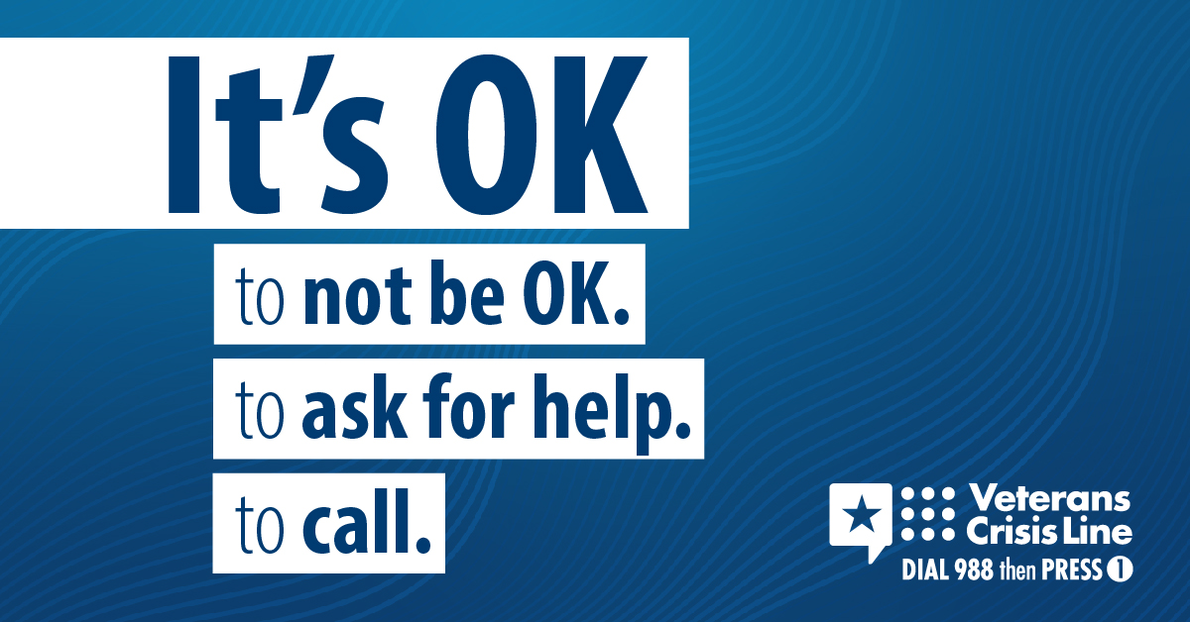  Instagram  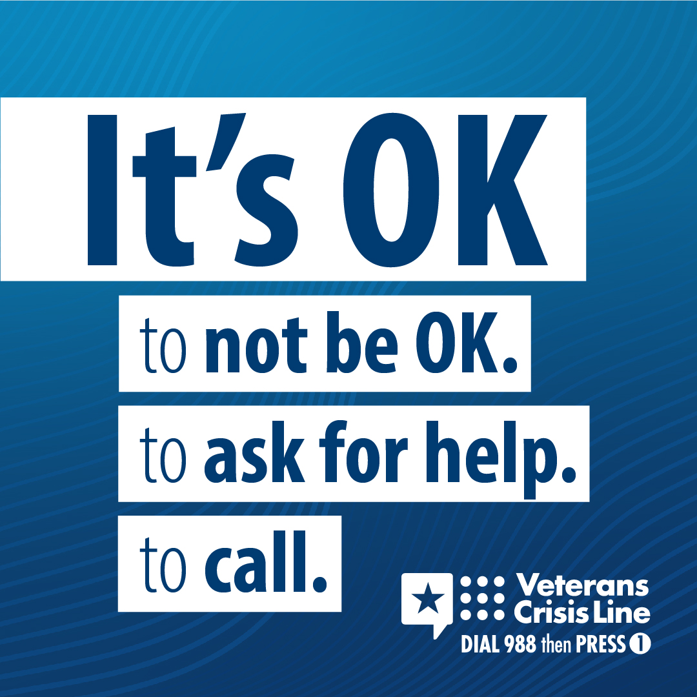
If you’re a Veteran in crisis or concerned about one, responders are available 24/7 to listen and help—Dial 988 then Press 1, chat at VeteransCrisisLine.net/Chat, or text 838255. | If you’re a Veteran in crisis or concerned about one, responders are available 24/7 to listen and help—Dial 988 then Press 1, chat at VeteransCrisisLine.net/Chat, or text 838255. | If you’re a Veteran in crisis or concerned about one, responders are available 24/7 to listen and help—Dial 988 then Press 1, chat at VeteransCrisisLine.net/Chat, or text 838255.  #SuicidePrevention  #SuicideAwareness | Facebook/X  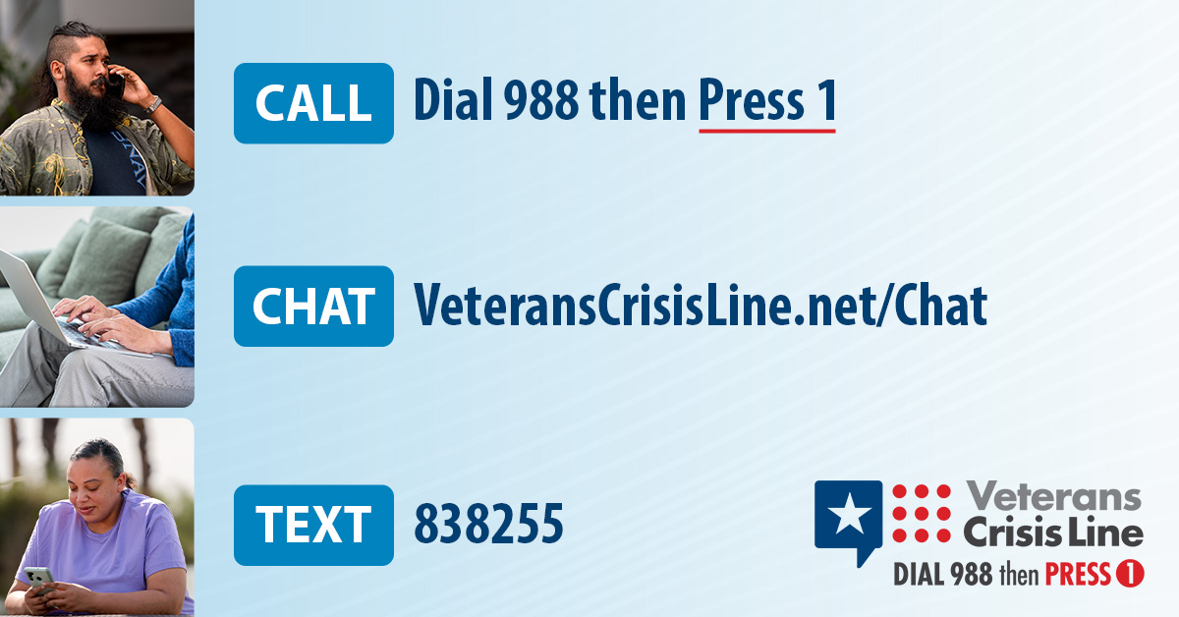  Instagram  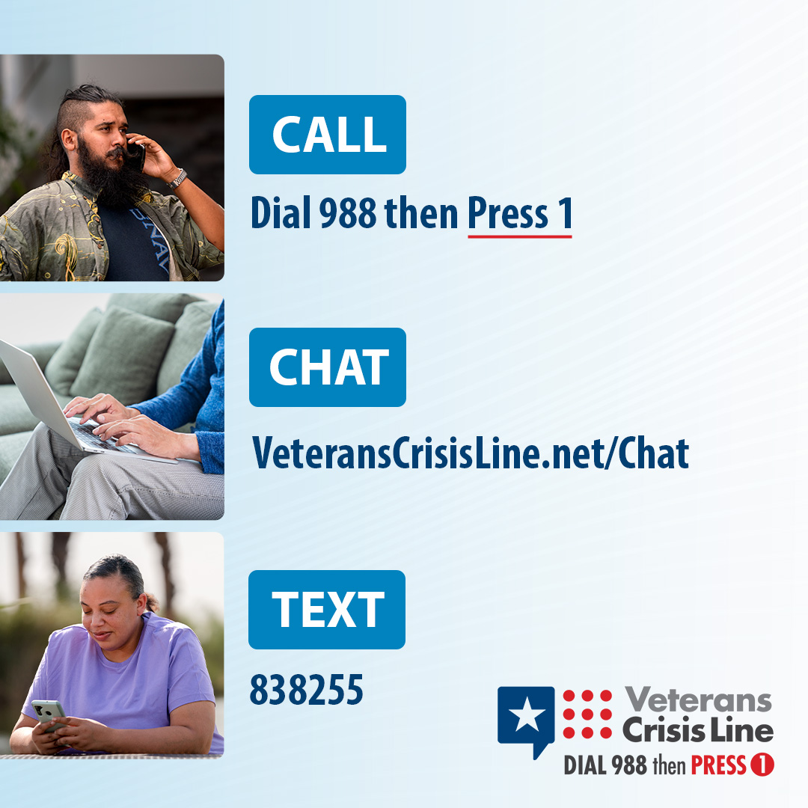
Looking for clinical care or counseling? This resource locator can help you find suicide prevention resources and support systems: VeteransCrisisLine.net/Find-Resources/Local-Resources | Looking for clinical care or counseling? This resource locator can help you find suicide prevention resources and support systems: VeteransCrisisLine.net/Find-Resources/Local-Resources | Looking for clinical care or counseling? This resource locator can help you find suicide prevention resources and support systems: VeteransCrisisLine.net/Find-Resources/Local-Resources  #SuicidePrevention  #SuicideAwareness | Facebook/X  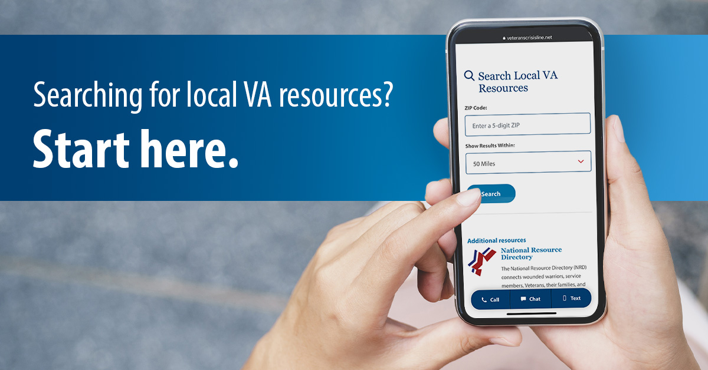  Instagram  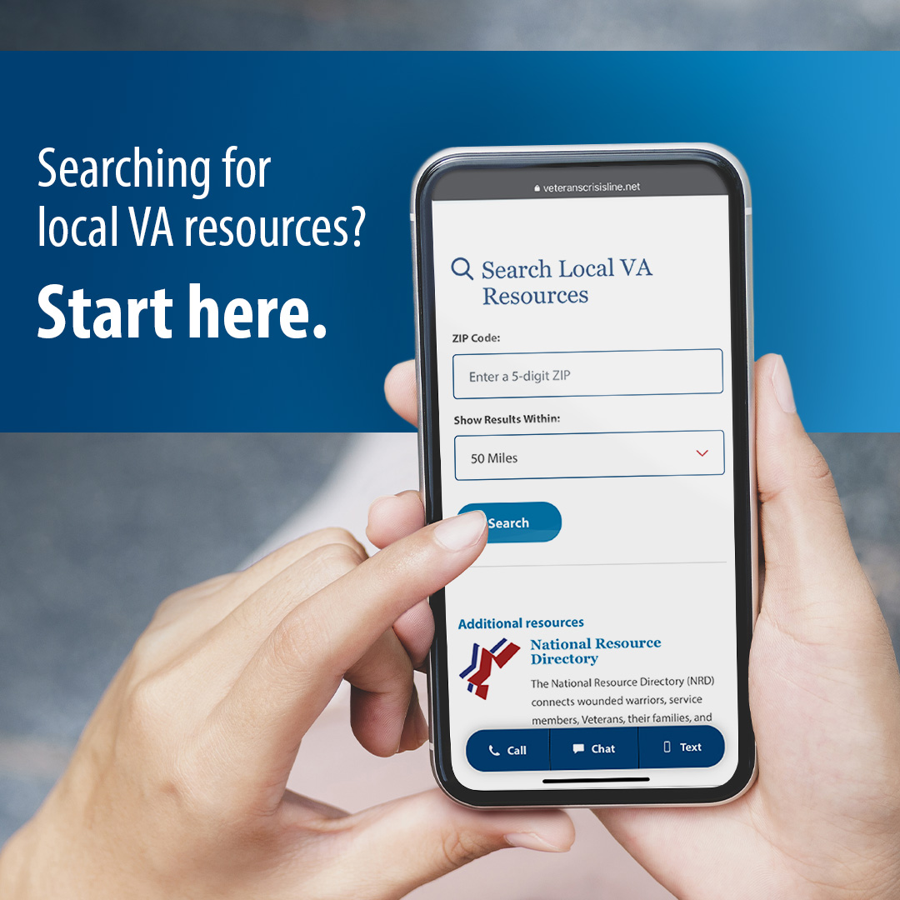
During a suicide crisis, every second counts. The Veterans Crisis Line is here to provide immediate support when you need it most. Caring and qualified responders are available to help 24/7. | During a suicide crisis, every second counts. The #VeteransCrisisLine is here to provide immediate support when you need it most. Caring and qualified responders are available to help 24/7. | During a suicide crisis, every second counts. The #VeteransCrisisLine is here to provide immediate support when you need it most. Caring and qualified responders are available to help 24/7.  #SuicidePrevention  #SuicideAwareness | Facebook/X  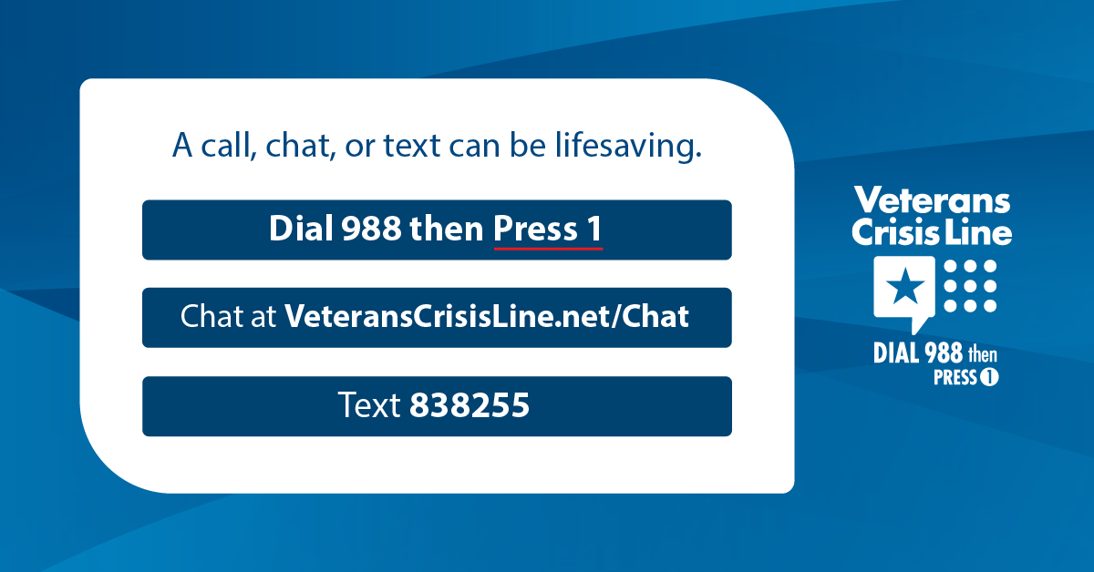  Instagram  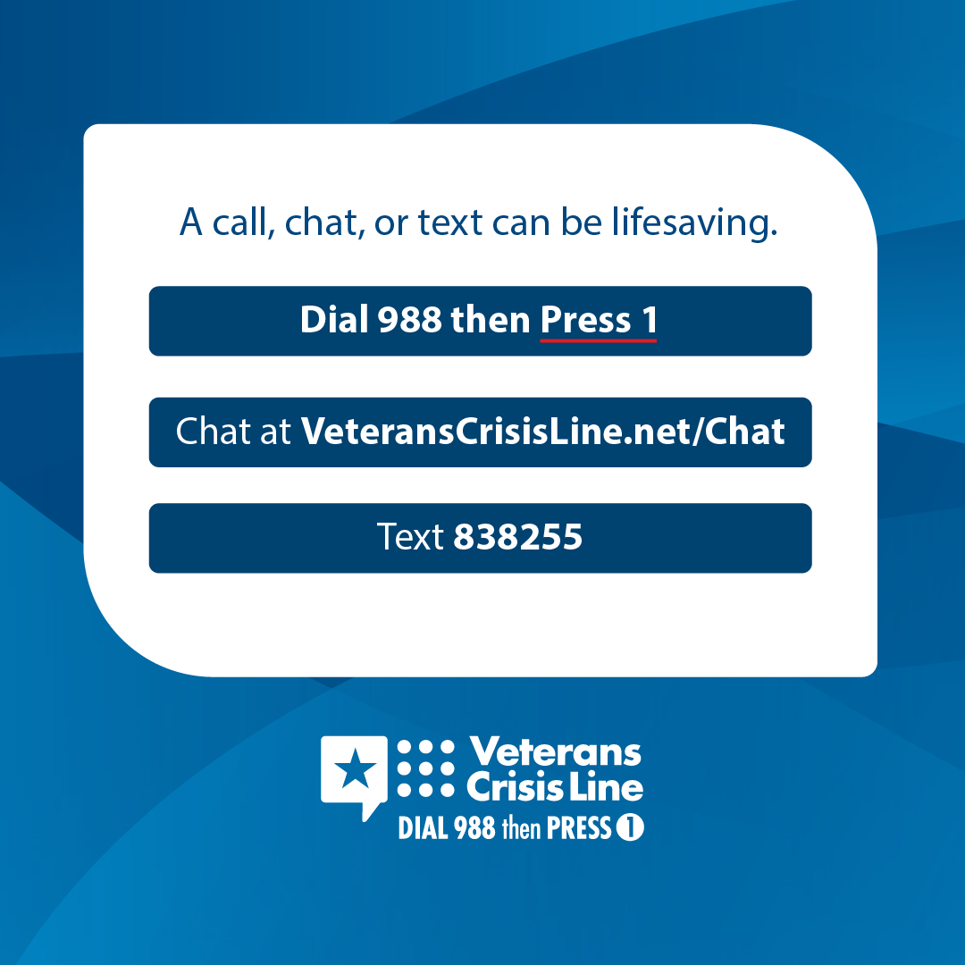
If you’re a Veteran in crisis, Dial 988 then Press 1, chat at VeteransCrisisLine.net/Chat, or text 838255 now. Responders are ready to listen and help. | If you’re a #Veteran in crisis, Dial 988 then Press 1, chat at VeteransCrisisLine.net/Chat, or text 838255 now. Responders are ready to listen and help. | If you’re a #Veteran in crisis, Dial 988 then Press 1, chat at VeteransCrisisLine.net/Chat, or text 838255 now. Responders are ready to listen and help.  #SuicidePrevention #SuicideAwareness | Facebook/X  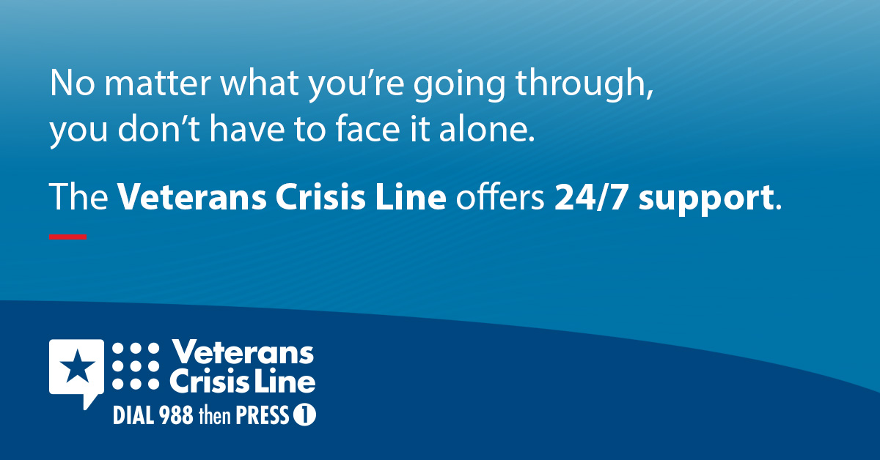  Instagram
You don’t have to be an expert to talk to a #Veteran in crisis. By showing genuine care through your words and actions, you can make an impact.  Learn how to talk with a Veteran who’s going through crisis: VeteransCrisisLine.net/Crisis  ConversationHandout. | You don’t have to be an expert to talk to a #Veteran in crisis. By showing genuine care through your words and actions, you can make an impact.  Learn how to talk with a Veteran who’s going through crisis: VeteransCrisisLine.net/Crisis  ConversationHandout | You don’t have to be an expert to talk to a #Veteran in crisis. By showing genuine care through your words and actions, you can make an impact.  Learn how to talk with a Veteran who’s going through crisis: VeteransCrisisLine.net/Crisis  ConversationHandout.  #SuicidePrevention  #SuicideAwareness | Facebook/X  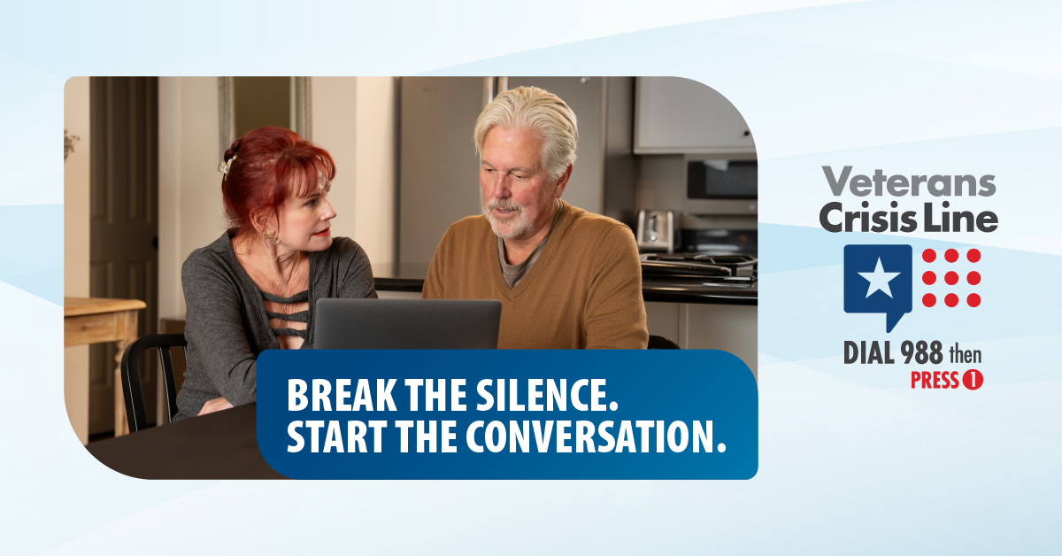  Instagram

